Activity Name: Feels Like Saving The World
Target Age Range: Students enrolled in first year Calculus.
Intended Learning Outcomes: In addition to deepening their understanding of social justice matters, I would like the student to realize how mathematics can be a vital analytical tool to understand our world and potentially change it for the better, and come to the realization of their own power as an individual and their ability to play an active role in society.
Resources Required:
- Pencil/Pen
- Paper
- Calculator
- Textbook
- Lecture Notes
Process: At the beginning of the semester the professor will introduce this activity that will prolong till the end of the semester. After each calculus concept taught, the professor will post the “Feels Like Saving The World” problem of the week each worth 3% of their final grade. The problem will be related to a social justice issue as well as integrating the calculus concept taught.

[ NOTE: I did not provide a problem of the week for every calculus concept, instead I provided the problem of the week pertaining to Optimization using Derivatives.]

Example #1 Problem Of The Week:

Improving Water Infrastructure in Rakhine State, Myanmar
Relief international is building on a three-year UNICEF program to improve access to clean water in Rakhine State, Myanmar. Amongst the many goals of this project is to repair the fencing to protect the water supply in six ponds. Relief international had come to the realization that one of the six ponds cannot be rectified, and requires to be built from scratch. In order to save finances for other project aims, they need to figure out the optimal amount of fencing to ensure the pond holds 556 gallons of water and the amount of fencing is minimized. (Note: The ponds are built on a square base.) Find out the width and height of the pond such that Relief International optimizes their finances.

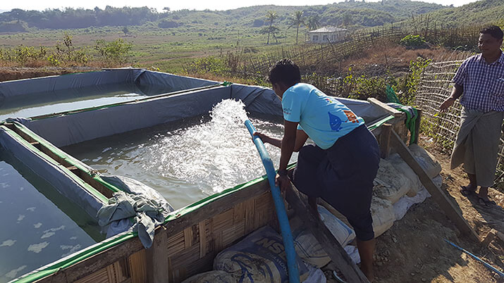

Reflection:
An Arabic saying that translates to: the knowledge taught at a young age is like carving into a rock, and the knowledge taught at an old age is like drawing on an ocean wave, inspired my activity. This is ultimately saying hat the best time to learn is in your youth. Although the assignment is intended for children, I chose to gear my audience to young adults. Primarily because I believe it is never too late to learn contrary to the above-mentioned saying. In addition to supporting social justice in a university classroom, I chose it to be conveyed to math majors. The reason being is because it is very easy for a student pursuing a non-social major to forget about other worldly matters. Therefore the integration of social justice and mathematics allows the student to learn about social justice problems and use their analytical skills to propose solutions.
Working as a Peer-Tutor and Mentor at Laurier’s Mathematics Assistance Centre (MAC), I have come across a reoccurring question from copious amount of students, that is “Why do I need to know this?” As a math student it is easy to lose motivation when course content seems pointless. With that being said, educators should take advantage of concepts that are hard to be applicable at the time, and integrate social justice and global citizenship matters in light of motivating the students and supporting social justice and global citizenship.

